**PROJECT PROPOSAL/TERRORISM IN THE WORLD FROM 1970 TO 2017**

Alice, Nick, Tifare, Juhlian

Proposal Objective:

We will demonstrate terror attacks from 1970 to 2017 through an interactive website, where the data was captured from: <https://www.start.umd.edu/gtd/>

Project Details:

Per the requirement, we will use three (4) images using Plotly to display Mapbox; by dates [iyear], locations [latitude, longitude], Bubble charts; by city[city], year[iyear], Heatmap; by dates [iyear, targettype1_txt] and Attacks by type, [attacktype1_txt, iyear, latitude, longitude] brings back attack types by category and countries.

Our record set is >100 records, will be housed in an SQLite database and brought back by a Restful API using Flask.

An HTML, CSS, and JS files will be housed in **HighCharts** which is an interactive tool that we’ve not used in class.

Project Images/Mockups:

**Mapbox Plots**/ iyear, latitude longitude (Tifari)

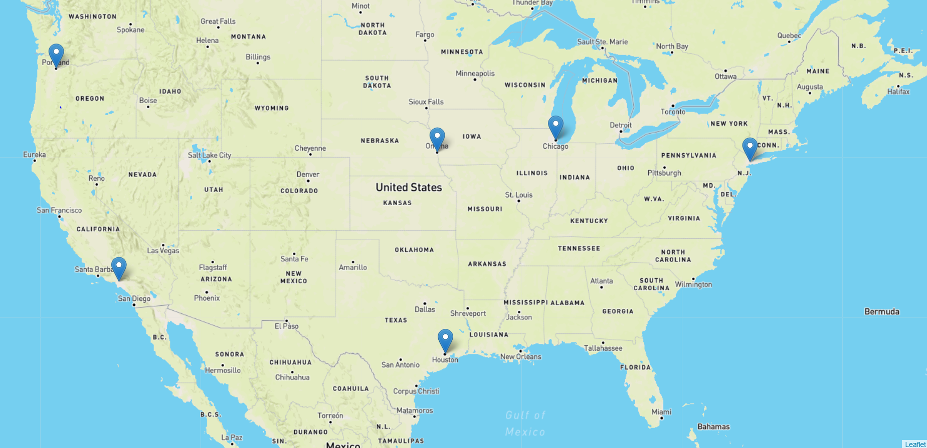

**Bubble Chart/**City/Year, by Volume (bubbles will vary in size)- (Alice)

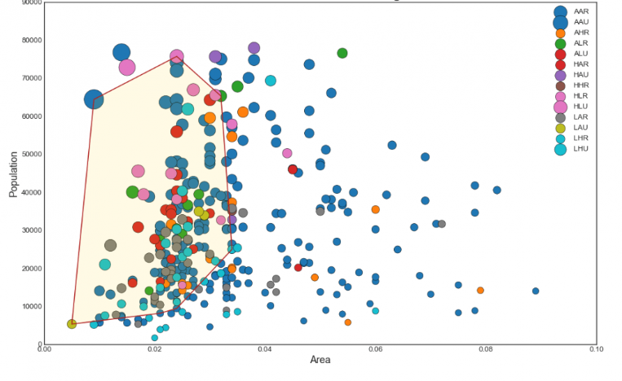

**Heatmap-and/or Line Chart/**iyear, targettyp1_txt (Juhlian)

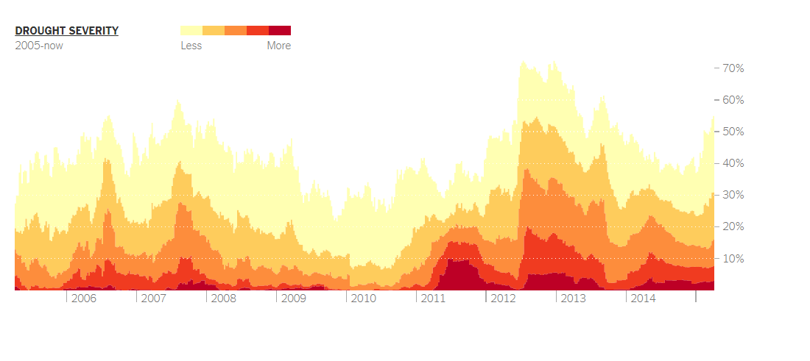

**Attacks by Location**/attackstype1_txt, iyear, longitude, latitude (Nick)

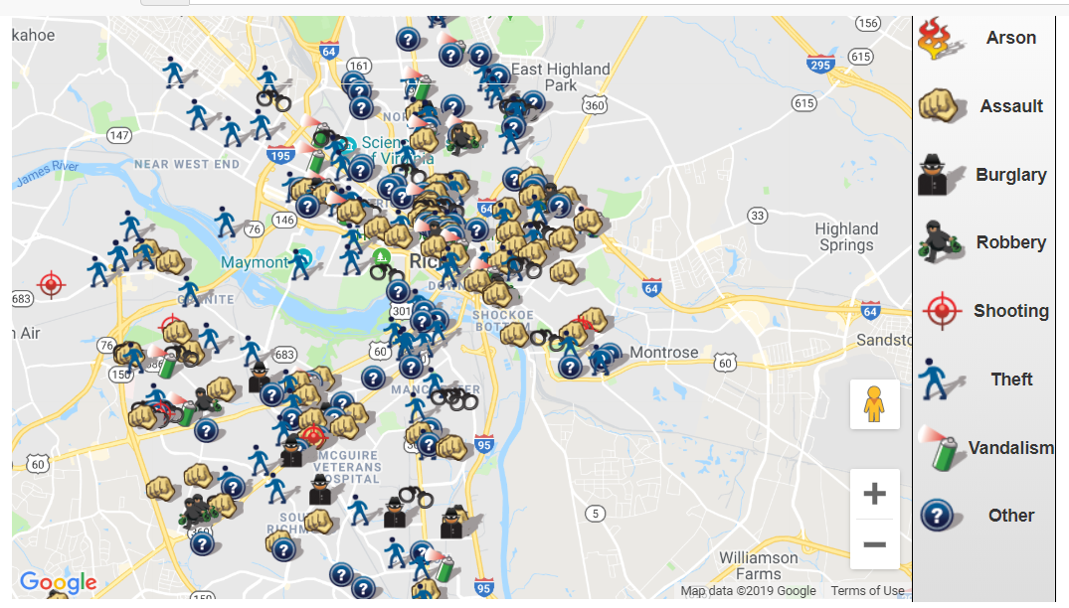

**PRESENTATION**

Introduction: 1 minute

The use of terrorism to further a political cause has accelerated in recent years. Modern terrorism largely came into being after the Second World War with the rise of Nationalist Movements in the old empires of the European Powers.

These early anti-Colonial movements recognized the ability of terrorism to both generate publicity for the cause and influence global policy.

What we are going to show you today is terror data from 1970 to 2017 for all interactive plots. Individually, we will be illustrating the data in differing views telling a slightly different story.

CHART 1—Tifari – 2 minutes

CHART 2- Alice – 2 minutes

This chart displays data by Country, with county by year. Starting with 1970, you can clearly see that the US had the most terror attacks when compared to other Countries… 1970- nationalists, ethnic terrorists, religious zealots, and anti-war militants frequently attacked American Targets

The following year in 1971, the UK increased in terror attacks. There have been many motives behind terrorism in [Great Britain](https://en.wikipedia.org/wiki/Great_Britain).[[1]](https://en.wikipedia.org/wiki/List_of_terrorist_incidents_in_Great_Britain#cite_note-1) During the [20th century](https://en.wikipedia.org/wiki/20th_century), most attacks were carried out by various [Irish Republican Army](https://en.wikipedia.org/wiki/Irish_Republican_Army) (IRA) groups and were linked to the [Northern Ireland conflict (the Troubles)](https://en.wikipedia.org/wiki/The_Troubles).

*In 1980, for the sake of time, it was El Salvador. There was a Civil War in this area from (1980-1992). However, in 1980, there was an increase in attacks due to assignation of their Archbishop and violence against American churchwomen*

*In 2000, India of all places had the most terror attacks*, a terrorist attack took place on [Red Fort](https://en.wikipedia.org/wiki/Red_Fort) in [Delhi](https://en.wikipedia.org/wiki/Delhi), [India](https://en.wikipedia.org/wiki/India). It was carried out by Pakistani terrorist group [Lashkar-e-Toiba](https://en.wikipedia.org/wiki/Lashkar-e-Toiba). It killed two soldiers and one civilian,[[1]](https://en.wikipedia.org/wiki/2000_terrorist_attack_on_Red_Fort#cite_note-1)[[2]](https://en.wikipedia.org/wiki/2000_terrorist_attack_on_Red_Fort#cite_note-2) in what was described in the media as an attempt to derail the India-Pakistan peace talks. Red Fort is an extremely important Indian facility as it hosts the Prime Minister of India annually on 15 August Which is Indian Independence Day.

2017- The largest terror attacks were in IRAQ and 2nd Afghanistan

CHART 3

BIG ‘OL MAP